

A computer is a machine with a set of built-in functions to finish specific tasks assigned by the user. The term "computer" is derived from the Latin word "*computare*" which means to calculate. ***("What is computer", n.d.)***

**WHAT IS A COMPUTER?**

***ESSENTIAL PARTS***

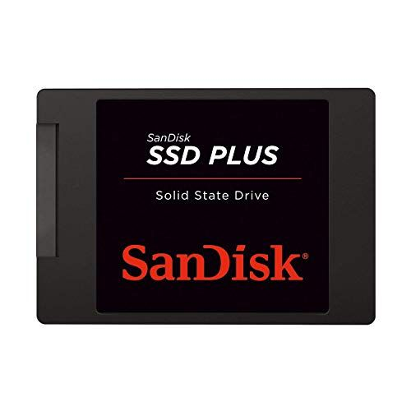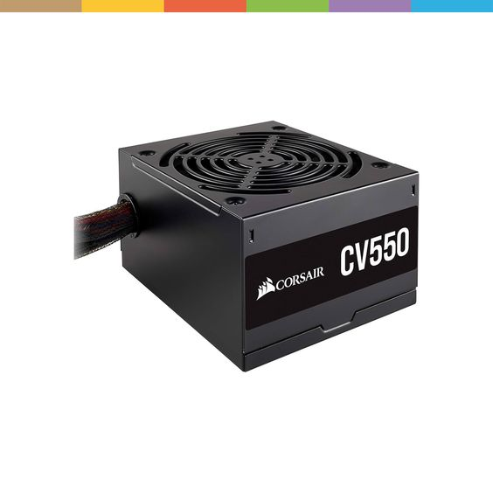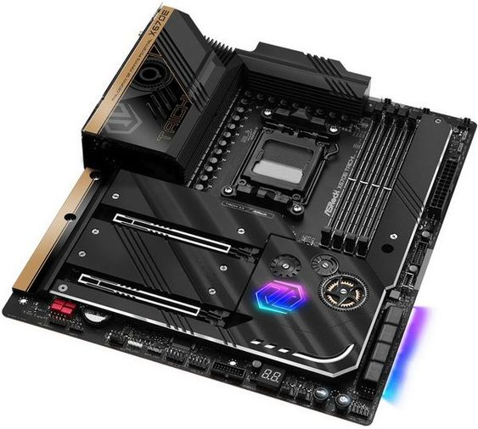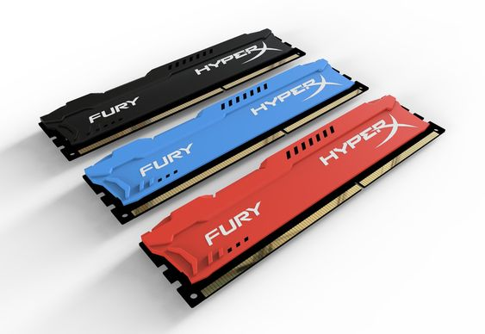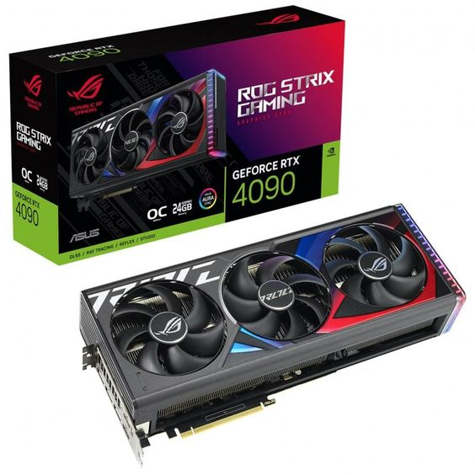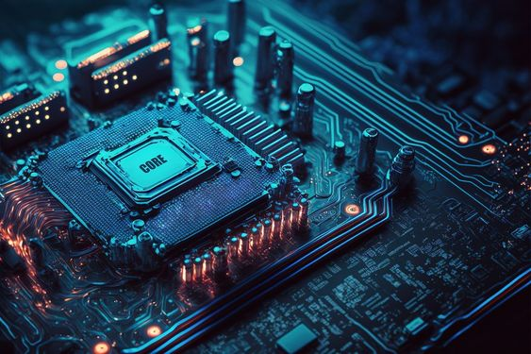

**Hdd / ssd**

**Power supply**

**Motherboard**

**RAM**

**GPU**

**CPU**

**NOTABLE INVENTORS**

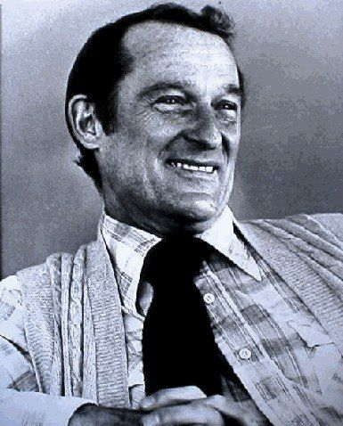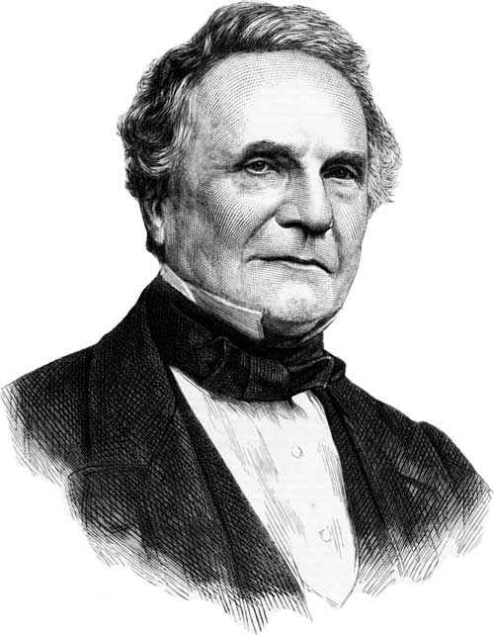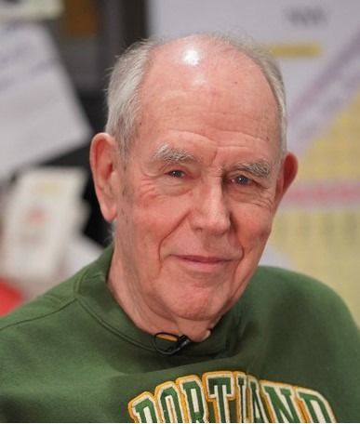

**Seymour Cray (September 28, 1925).** Cray, considered the “***father of supercomputing***,” had left his post at business computing giant Sperry-Rand to join the newly formed Control Data Corporation so that he can focus on developing scientific computers. The title of world’s fastest computer was held at the time by the IBM 7030 “Stretch,” one of the first to use transistors instead of vacuum tubes (Nguyen, 2019).

**Ivan E. Sutherland (May 16, 1938).** he was known as the inventor and developer of the ***interactive computer graphics***. They founded Evans and Sutherland Computer Corporation, where Sutherland served as vice president and chief scientist ("Ivan Edward Sutherland", n.d.).

**Charles Babbage (December 26, 1791).** An English polymath, is often thought of as "***the man who invented computers***.” From 1822 until his death in 1871, he designed three computers, but never actually constructed any of them due to lack of funding (Barfield, 2020).

**HARDWARE DEVELOPERS:**

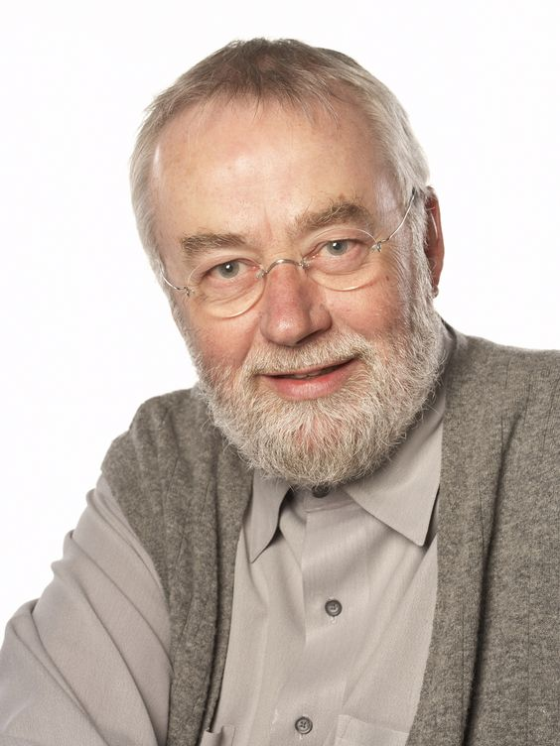

**Bill Moggridge** designed the ***GRiD Compass laptop*** (1982), the first laptop, around an early flat screen produced by Sharp. This was a yellow-on-black electroluminescent panel that could display 80 characters of text and 320 x 240 pixel graphics.

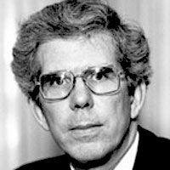

**Philip Don Estridge** led development of the original IBM Personal Computer, and thus is known as “***father of the IBM PC***”. Don Estridge gave Skellings' corporation an IBM contract to develop the Electric Literature series which featured the “Electric Poet” software. (Estridge, Philip D., n.d.)

**NOTABLE INVENTORS**

**SOFTWARE DEVELOPERS:**

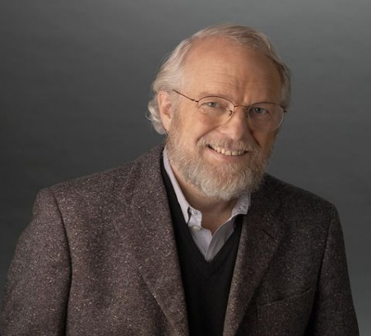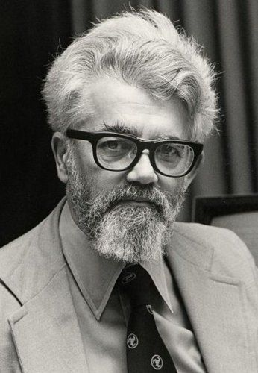

**John McCarthy (September 4, 1927)** was an American computer scientist who contributed significantly to areas of computer science and mathematics. His contributions paved the way for inventions in ***artificial intelligence*** and ***interactive computing systems*** (Avinash, 2024).

**John Warnock (1940)** known as a co-founder of ***Adobe Inc.***, has pioneered the development of graphics, web and electronic document technologies that have revolutionized the field of publishing and visual communication. Dr. Warnock holds seven patents ("John Warnock", n.d.).



**Linus Torvalds** is a software engineer best known for developing the ***Linux kernel***, which is an essential component of the Linux operating system. His invention transformed the open-source software community and has since been widely used in a variety of applications. Torvalds’ efforts have sparked

collaborative development and spawned a thriving community of developers who **contribute to the Linux environment (Avinash, 2024).**

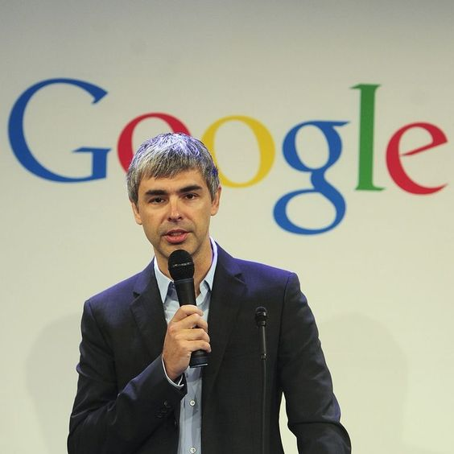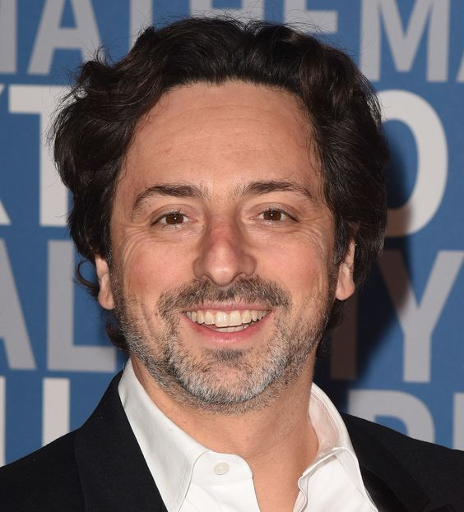

**Sergey Brin and Larry Page,** the founders of ***Google***. Google began as a search project by Larry Page and Sergey Brin when they were Ph.D. students at Stanford University. The search engine algorithm they developed was unique because it ranked pages not only based on their content, but on how many other webpages linked back to them (Britannica, 2023).

**Bill Gates,** who is best known as the founder of ***Microsoft***, an American multinational company located in Washington, is the largest developer of software and technological resources today.

**REFERENCES:**

**a. Barfield, R. (2023). Who invented computers? Retrieved from https://www.bricsys.com/en-eu/blog/who-invented-computers**

**b. Ivan Edward Sutherland. (n.d.). Retrieved from https://history.computer.org/pioneers/sutherland.html**

**c. National Inventors Month: 15 famous computer scientists and their inventions. (n.d.). Retrieved from https://www.turing.com/blog/famous-computer-scientists-and-their-inventions**

**d. Nguyen, T. C. (2019). Who invented the supercomputer? Retrieved from https://www.thoughtco.com/history-of-supercomputers-4121126**

**e. What is computer: Types and advantages - javatpoint. (n.d.). Retrieved from https://www.javatpoint.com/what-is-computer**

**f. John McCarthy. (n.d.). Retrieved from https://www.britannica.com/biography/John-McCarthy**

**g. The history of PC hardware, in pictures - pingdom. (n.d.). Retrieved from https://www.pingdom.com/blog/the-history-of-pc-hardware-in-pictures/**

**h. Obituary: Bill Moggridge, inventor of the first laptop computer. (n.d.). Retrieved from https://www.zdnet.com/article/obituary-bill-moggridge-inventor-of-the-first-laptop-computer/**

1. **Britannica money. (2024a, August 9). Retrieved from https://www.britannica.com/money/Larry-Page**

**j. Britannica money. (2024b, August 14). Retrieved from https://www.britannica.com/money/Bill-Gates**

**k. Computer History Museum. (2024a, June 19). John McCarthy - CHM. CHM. Retrieved from https://computerhistory.org/profile/john-mccarthy/**

**l. Computer History Museum. (2024b, June 19). John Warnock - CHM. CHM. Retrieved from https://computerhistory.org/profile/john-warnock/**

**m. Don Estridge - Computing History. (n.d.). Retrieved from https://www.computinghistory.org.uk/det/1788/Don-Estridge/**

**n. Linus Torvalds | Lemelson. (n.d.). Retrieved from https://lemelson.mit.edu/resources/linus-torvalds**